Power Electronics

Boost Converter

Taegeon Han & Jaehee Kim, Steel Hard

05/07/23

**Question 1**. From the PSIM Circuit of the Boost converter shown in Fig. 2, the inductor current has $Δi_{L} = 2A$. It is operating in dc steady state under the following conditions: $V_{in} = 5 V$, $V_{out} = 12 V$, $P_{out} = 11 W$, and $f_{s} = 200 kHz$.

(a) Assuming ideal components, calculate L and draw the waveforms of duty, MOSFET voltage, inductor voltage, inductor current, diode current and capacitor current.

$$D=1-\frac{V_{in}}{V_{out}}=\frac{7}{12}≈0.5833$$

$$L=\frac{V_{in}⋅D}{Δi_{L}⋅f_{s}}=7.291[μH]$$

$$R_{Load}=\frac{V_{out}^{2}}{P_{out}}=13.0909[Ω]$$

$$I_{L}=I_{in}=\frac{P_{in}}{V_{in}}=\frac{P_{out}}{V_{in}}=\frac{1}{V_{in}}⋅\frac{V_{out}^{2}}{R_{Load}}=\frac{1}{V_{in}}⋅\frac{{\left(\frac{V_{in}}{1-D}\right)}^{2}}{R_{Load}}=\frac{V_{in}}{{\left(1-D\right)}^{2}⋅R_{Load}}=2.2[A]$$

$$I_{L\left(max\right)}=I_{L}+\frac{Δi_{L}}{2}=3.2\left[A\right]$$

$$I_{L\left(min\right)}=I_{L}-\frac{Δi_{L}}{2}=1.2\left[A\right]$$

$$I_{out}=\frac{V_{out}}{R_{Load}}=0.9167\left[A\right]$$

$$T_{on}=D⋅T_{s}=D⋅\frac{1}{f_{s}}=2.915[μs]$$

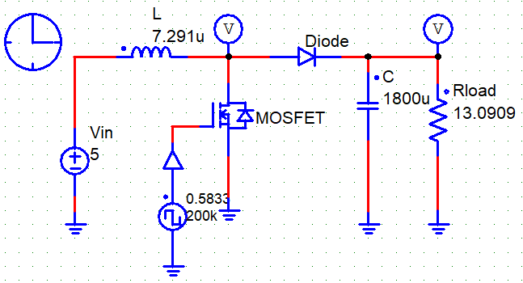

Figure 1. Circuit of Boost Converter

Figure 2. waveforms of duty

Figure 3. waveforms of MOSFET Voltage

Figure 4. waveforms of Inductor Voltage

Figure 5. waveforms of Inductor Current

Figure 6. waveforms of Inductor Current

Figure 7. waveforms of MOSFET Current

The equations and graphs above indicate that the theoretical values of voltage and current for the devices in the boost converter circuit are consistent with the simulation values.

**Question** **2.** In a Boost converter, $L = 25 μH$. It is operating in dc steady state under the following conditions: $V_{in} = 12 V$, D = 0.4, $P_{out} = 25 W$, and $f_{s} = 400 kHz$. Assume ideal components. Calculate the critical value of the output load $R_{Load}$ and $P_{out}$ below which the converter will enter the discontinuous conduction mode of operation.

$$V_{out}=\frac{1}{1-D}×V_{in}=\frac{1}{1-0.4}×12=20\left[V\right]$$

To enter DCM of operation,

$$I_{L(crit)}= ∆i_{L}=\frac{V_{in}}{2L}DT_{s}=0.24[A]$$

$$P_{out\left(crit\right)}=P_{in}=V_{in}I_{in}=V_{in}I_{L\left(crit\right)}=2.88[W]$$

$$R_{load}=\frac{P_{out\left(crit\right)}}{I_{L\left(crit\right)}^{2}}=50[Ω]$$

**Question** **3.** In the Boost converter from problem 2, the input voltage is varying in a range from 9V to 15 V. For each input value, the duty-ratio is controlled to keep the output voltage constant at its nominal value (with $V_{in}$ = 12 V and D = 0.4). Calculate the critical value of the inductance L such that this Boost converter remains in the continuous conduction mode at and above $P_{out}$ = 5 W under all values of the input voltage $V_{in}$. (Check Appendix )

To remain CCM of operation,

$$I_{L} ≥ I_{L\left(crit\right)}= ∆i_{L}=\frac{V_{in}}{2L}DT_{s}$$

$$P_{in}=V_{in}I_{in}=V_{in}I_{L}=P_{out}$$

$$L≥\frac{V_{in}^{2}}{2P_{out}}DT_{s}=\frac{V_{in}^{2}}{2P_{out}}⋅\frac{1}{f_{s}}\left(1-\frac{V_{in}}{V_{out}}\right)$$

$$V_{out}=\left(\frac{1}{1-D}\right)V_{in}=20[V]$$

$$L_{crit}=\frac{V_{in}^{2}}{2⋅5\left[W\right]⋅400\left[kHz\right]}\left(1-\frac{V_{in}}{20\left[V\right]}\right)$$

The value we want to find is the value of L that operates as a CCM in all intervals of 9[V] ≤ $V_{in}$ ≤ 15[V] when $P_{out}$ =5[W], so finding the maximum value of L will satisfy the conditions in all intervals.

The maximum value is the point where the gradient of the derivative becomes zero,

$$\frac{dL_{crit}}{dV_{in}}=\frac{V_{in}}{5\left[W\right]⋅400\left[kHz\right]}-\frac{3V_{in}^{2}}{2⋅5\left[W\right]⋅400\left[kHz\right]⋅20\left[V\right]}=0$$

$$V_{in}=13.333[V]$$

$$∴L_{crit}\left(13.333\right)=14.8148[μH]$$

Using MATLAB, we can also find the solution.

Figure 8. MATLAB Results about

Figure 9. MATLAB Results about Question 3

**Question** 4**.** A Boost converter is to be designed with the following values: $V_{in}$ = 5 V, $V_{out}$ = 12 V, and the maximum output power $P_{out}$ = 40 W. The switching frequency is selected to be $f_{s}$ = 400 kHz. Assume ideal components. Estimate the value of L if the converter is to remain in CCM at one-third the maximum output power.

$$V_{out}=\frac{1}{1-D}V_{in}, D=\frac{7}{12}≈0.583$$

$$P_{out}=P_{in}=\frac{40}{3}[W]$$

To remain CCM of operation,

$$L≥\frac{DD^{'2}}{2}RT_{s}$$

$$I_{L}=\frac{P_{out}}{V_{out}}=\frac{\frac{40}{3}}{12}=1.11[A]$$

$$R=\frac{V}{I_{L}}=\frac{12}{1.11}=10.81[Ω]$$

$${∴L}_{crit}=\frac{DD^{'2}}{2f_{s}}R=\frac{0.583×{\left(1-0.583\right)}^{2}}{2×400k}×10.81=1.37\left[μH\right]$$